Important Reminders

* Send in full change of clothes.
* Fill out all papers and return to Ms. Heggs.
* School starts at 8:20 and ends at 3:05.

This Month in Kindergarten We Are Working On:

* Writing our names with only 1 capital letter.
* Counting to 30.
* Comparing numbers.
* Writing numbers to 10.
* Letters e, r, p, j, l, h, k, v, and w.
* Identify the main topic and supporting details in a text.

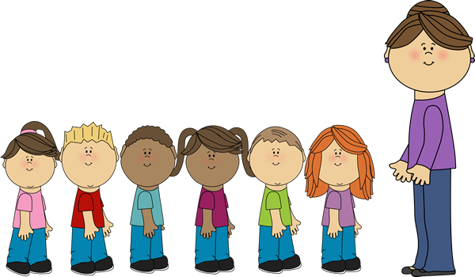Kindergarten News

Note from Ms. Heggs

Reading

Your child will listen to a read aloud in class every day. In order to develop a healthy reading habit, I encourage you to read to your child every day and ask the child who, what, when, why, and how questions about the story.

Math

We will be starting the year with GKIDS and

i-Ready diagnostic. This will help me get to know your child as a math thinker and problem solver. Our first unit of the year will be about counting with friends!

Birthdays

(No Birthdays in the Month of October)

Have an awesome month!

Ms. Heggs ☺